Cover Page

Title and Subtitle

Example



Snapshot of the final Product

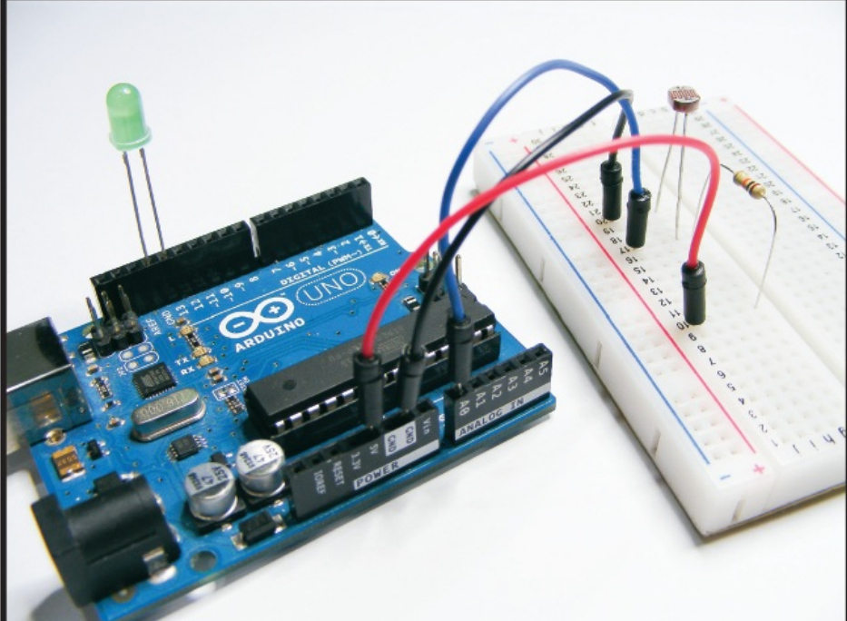

Table of contents

Table of Figures

Introduction

Aims Objectives

Justification—Rich Picture and its description

Parts Required and Its Photos with Photo comments

How it works

The Build or Circuit Layout

The sketch

Trouble shooting

Other applications

References